1. Identify the following symbols:



✓
Bulb Bulb Bulb Bulb

✓
Cell (battery) Cell (battery) Cell (battery) Cell (battery)
✓
Motor Motor Motor Motor
✓
Switch Switch Switch Switch

2. Draw a diagram of the circuit pictured below, using the correct symbols:
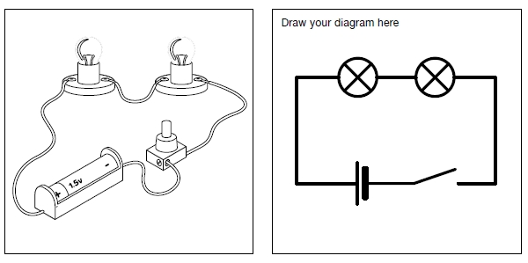

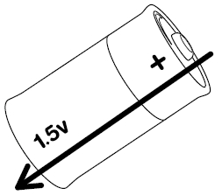
3. Look at the battery below: Indicate which is the positive end and which is the negative end.

Draw an arrow to show the direction that the electricity will flow through the battery.

What is the voltage of this battery? _1.5 volts____

4. Look at the circuit diagrams below. In the space underneath each circuit indicate whether or not you think the circuit will make the bulb light up and, if not, explain why?
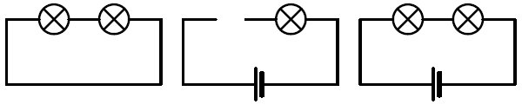

Answer: the bulbs will not light up as there is no battery to___
power them.______________

Answer: The bulb will not light up as the circuit is not joined_
up._____________________

Answer: This is a complete__
circuit so the bulb will light___
up._____________________

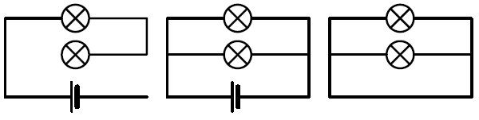

Answer: the bulbs will not ight
up as the circuit is not joined_
up.______________________

Answer: This is a complete___
circuit so the bulbs will light__
up.______________________
Answer: The bulbs will not light up as there is no battery to power them.___________

5. Why do we need electricity meters?
Answer: To measure how much electricity you use in your house.________________________ ____________________________________________________________________________

6. Why do we need a circuit breaker in a house?
Answer: It protects a house by switching off the electricity supply if there is a fault.___________
____________________________________________________________________________

7. What is a fuse?
Answer: It is a safety device that is inside an electric plug. It shuts off the electricity if there is a
fault.________________________________________________________________________

